**CT Screen Recorder**

**Description:** This software is used to record screen in different resolution type namely High, Medium, Low.

**Authors**: Rakesh Gupta

**Date**: August 2018

**Reviewer**:

**Keywords**: Screen Recorder, Resolution

CitiusTech has prepared the content contained in this document based on information and knowledge that it reasonably believes to be reliable. Any recipient may rely on the contents of this document at its own risk and CitiusTech shall not be responsible for any error and/or omission in the preparation of this document. The use of any third party reference should not be regarded as an indication of an endorsement, an affiliation or the existence of any other kind of relationship between CitiusTech and such third party.

**Document Control**

|  |  |
| --- | --- |
| Version | 1.0 |
| Created by | Rakesh Gupta, Siddhesh Shingre |
| Updated by |  |
| Reviewed by | Prithu George |
| Date |  |

**Table of Contents**

1. Introduction 3

2. Pre-requisites 3

3. Project Details 3

3.1. What does it do? 3

3.2. How it is used? 3

4. Code Files 7

5. Testing 7

6. Contribute to fixes/patches 7

7. Known Issues 7

# Introduction

CT Screen Recorder is used to record on screen activity with different resolution type.

This resolution type is as below:

|  |  |
| --- | --- |
| **Resolution Type** | **Resolution** |
| High Resolution | 1366 x 768 |
| Medium Resolution | 1280 x 720 |
| Low Resolution | 200 x 75 |

# Pre-requisites

* Java 7 or higher version

# Project Details

## What does it do?

* CT Screen Recorder is used to record all resolution screen activity.
* It created Low, Medium & High Level resolution.
* For low Level Resolution there is video compression algorith that is implemented which would be helpful to reduce size of file created.
* Final file would have .mp4 extention.

## How it is used?

* + 1. **Get the codebase on your local machine**

Copy Software from this location <http://10.30.5.71/siddheshs/CTScreenRecorder.git> on the local system

* + 1. **Working with CT Screen Recorder**
       1. **User Input Fields**

After saving Software to your local workstation, run the software by double clicking on the same.

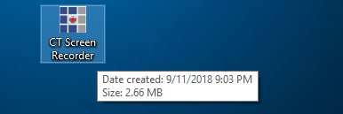

Post Double clicking it will open application as below where you can set your preferred resolution type for recording

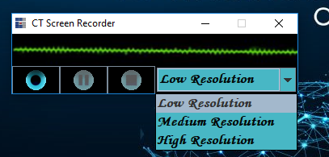

* If user selects – Low Resolution
* .mp4 file will be created at the end of recording with video file compressed using compression algorithm to reduce video file size.
* Resolution Type would be 200 x 75
* If user selects – Medium Resolution
* .mp4 file will be created at the end of recording without any compression algorithm applied.
* Resolution Type would be 1280 x 720
* If user selects – High Resolution
* .mp4 file will be created at the end of recording without any compression algorithm applied.
* Resolution Type would be 1366 x 768

**Functionality**

* Initial Splash screen to be appeared till actual application loads.



* Initially Start button would be enabled whereas Pause and Stop button would be disabled.

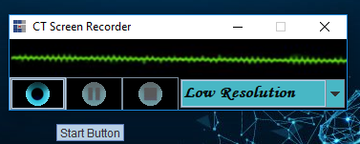

* Once User click on Start button Pause and Stop button would be activated.

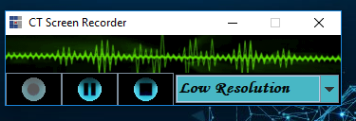

* If user clicks on Pause; Resume and Stop button would be activated.

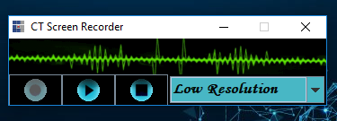

* If user clicks on Stop button, application would be closed and video would be created in CTRecordings folder at the same place where we have CT Screen Recorder Software place on local drive.

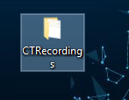

* + - 1. **Software Output**
* User message when recording is completed successfully.

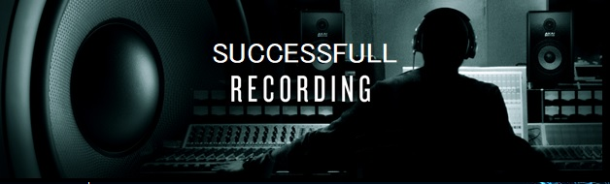

* Post above user messages is encountered; video file would be created in path where software is placed.

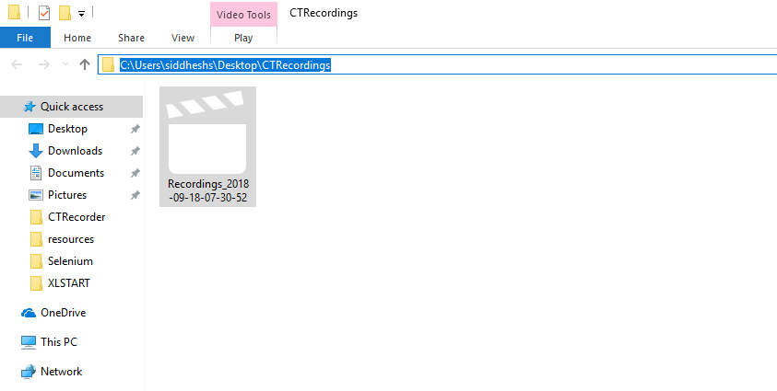

* + - 1. **Readings – File Size**

# Code Files

* Please find the source code -

# Testing

* Testing is completed. All the functions and buttons are working as expected and as per the requirement

# Contribute to fixes/patches

Contact persons for contributing to fixes and patches are as follows:

* Rakesh Gupta - [Rakesh.gupta@citiustech.com](mailto:Rakesh.gupta@citiustech.com)
* Siddhesh Shingre - [Siddhesh.shingre@citiustech.com](mailto:Siddhesh.shingre@citiustech.com)

# Known Issues

N/A